**W2-S2** PRACTICE

*OOP MANIPULATION*

## *Learning objectives*

* Implement a class in Dart with specific **attributes and methods**
* Define and use default constructors.
* Implement **named constructors** and **parameterized constructors**.
* Implement **Value Objects, immutable objects**
* Manipulate **enumerations**
* Handle **Exceptions**
* Identify **const** and **final** attributes
* Be able to **encapsulate** data (private members, getters)
* Implement Operator **Overloading**
* Implement **aggregation** and **composition** of classes

 *No AI tools allowed to solve this practice*

## *How to submit?*

* **Push** your final codeon **your GitHub repository**
* Then **attach the GitHub path** to the MS Team assignment and **turn it in**

## *Are you lost?*

*Read the following documentation to be ready for this practice:*

* [Classes](https://dart.dev/language/classes)
* [Constructors](https://dart.dev/language/constructors)
* [Methods](https://dart.dev/language/methods)

# EX 1 – Employee Class



*In this exercise, you will be working on an existing Employee class.* ***Read the start code!***

We provide the start code of the Employee class and the main that creates a few instances of Employee.

We also provide the Skill enum with various values.

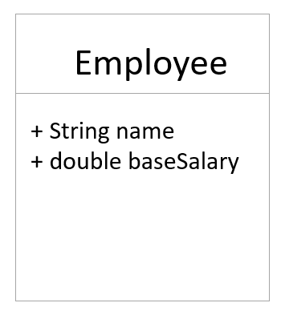 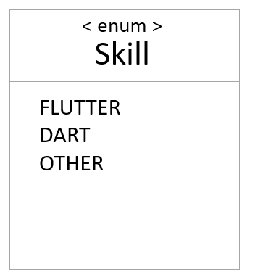

**Q1**- Add the following **new attributes to the Employee class:**

* skills: A list of skills
* address: An Address class that contains street, city, and zipCode attributes
* yearsOfExperience: An integer representing the employee's experience in years

**Q2** - **Update the constructor** to initialize the new attributes.

Add [**named constructors**](https://dart.dev/language/constructors#named-constructors) for specific types of employees

*Example: mobileDeveloper constructor that assigns FLUTTER and DART skills*

**Q3** - Make all attributes **private** and **provide getter** methods for accessing them.

**Q4** – Add a method to **compute the salary** of the employee *(you can create your own rules!):*

Salary Specification:

Base salary: $40,000.

Each year of experience adds $2,000.

Each skill adds a different bonus:

* FLUTTER: $5,000.
* DART: $3,000.
* OTHER: $1,000.

*Note: don’t forget to define attributes const or final whenever possible!*

# EX 2 – Bank System



*In this exercise, you will be working on a Bank account and a Bank class.* ***Read the start code!***

**Bank Account**

**Q1 -** Decide which attributes make sense for a bank account

**Q2 –** Implement the following methods

balance():

* Returns the current balance

withdraw(double amount)

* Deducts the given amount from the account balance.
* If the balance goes below 0, it should throw an exception.

credit(double amount)

* Adds the given amount to the account balance.

**Bank**

**Q3 -** Decide which attributes make sense for a bank

* The Bank class manages a list of accounts and ensures the uniqueness of each account ID.

**Q4 –** Implement the following method

Account createAccount(int accountId, String accountOwner)

* Create a new bank account
* Ensure that the account ID is unique. Otherwise, throw an exception
* Add the account to the bank list and return it

**Q5 –** Draw a UML class diagram that reflects your implementation.

* Attributes and methods of the BankAccount class.
* The relationship between Bank and BankAccount (composition or aggregation)

# EX 3– Duration



*In this exercise, you need to create a CustomDuration class, similar to Dart's built-in Duration.*

<https://api.dart.dev/stable/3.5.3/dart-core/Duration-class.html>

You need to understand:

* the concepts of **immutability**
* operator **overloading**
* custom **methods**

**Q1 –**Attribute and constructors

* Internally store the duration as a number of milliseconds (private field).
  + **Duration shall always be greater or equal to 0**
* Constructor:
  + fromHours(int hours): Constructs a duration from a number of hours
  + fromMinutes(int minutes): Constructs a duration from a number of minutes
  + fromSeconds(int seconds): Constructs a duration from a number of seconds

**Q2-** Overloaded Operators:

* >: Compare two durations, returning true if one duration is greater than the other.
* +: Add two durations, returning a new CustomDuration object.
* -: Minus two durations, returning a new CustomDuration object *(if possible)*

# EX 4 – Shop Management



A shop sells **products** that customers can **order online**.  
An **order** can be **delivered** to an address or **picked up** at the shop.  
We must compute each order’s **total amount**.

**Learning Objectives**

Design a simple **Online Shop system** using Dart concepts:

* Constructors (named, required, nullable)
* Enums
* UML class diagrams
* Object relations and methods

**Questions**

**Q1 - UML**

* Draw a **UML diagram** showing classes, attributes, and relationships.  
  *Be ready to explain your choices to other students or the classroom*

**Q1 - Implementation**

* Implement the Dart classes and methods to solve this problem.

*How can we get the order total amount?*

* In main(), create sample data and test your API

**✅ Deliverables**

* UML diagram
* Dart code file